

Version Number: 1.0

Version Date: 2019-05-03



Revision Log

|  |  |  |  |
| --- | --- | --- | --- |
| Version | Date | Author | Change Description |
| 1.0 | 2019-05-03 | Deanna Beauchamp | Initial creation |
|  |  |  |  |
|  |  |  |  |
|  |  |  |  |

Contents

1. Overview 1

2. High Level Process 2

2.1. Ad-hoc Process 3

2.2. Monthly Process 4

# Overview

The purpose of the financial component in NGN’s Dynamics 365 instance is to help facility reconciliation, budgeting and reporting.

There are 3 main financial entities:

* Financial Category – the category type of the transaction
* Financial Line Item – the record of each transaction
* Financial Monthly Summary – a summary of all line items for a Vendor and Category for a month

Financial categories help classify the financial line items and financial monthly summary records into NGN relevant groupings.

A Financial Line Item record is created every time there is a one-time charge or monthly charge (either full or prorated). A line item may also be created when there is a change to the site service and the previous service needs to be charged for retroactively. The line item contains the cost as well as the recoverable cost (the amount charged back to the School District).

Financial Monthly Summary records are created monthly for each Vendor and for each of their Financial Categories. The Financial Line Items are child records under the summary record which allows for a rollup (summary) of costs and recoverable costs. There is also a field to enter the actual amount of the bill from the Vendor for that Category as well as any relevant notes.

# High Level Process

When a new Site Service is added:

* A One Time Charge line item will be created if needed (Ad-hoc)

When a Site Service is changed (upgraded/downgraded):

* A One Time Charge line item will be created if needed (Ad-hoc)
* A prorated line item for the previous Site Service (Ad-hoc)
* A prorated line item for the new Site Service (Monthly)

When a Site Service is removed (deactivated):

* A prorated line item for the removed Site Service (Ad-hoc)

When the Monthly Summary record is created:

* A monthly charge line item is created for each site service (Monthly)

## Ad-hoc Process

Ad-hoc processes run when the Site Service is updated.

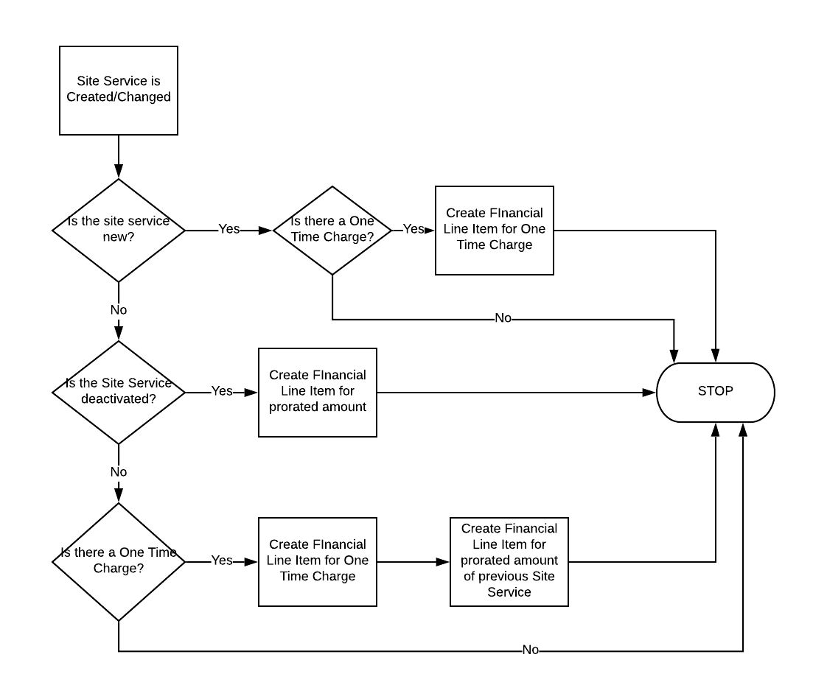

## Monthly Process

Monthly processes run when the Financial Monthly Summary record is created, which should be monthly.

